Assignment 3: Relational Algebra

1. **Select the make_name and model_name of all vehicles which have a first production year of 1976**

π Make.make_name, Model.model_name

(σ Model.first_production_year = 1976

((Model ⋈ Model.model_id = Vehicle.fk_model_id Vehicle)

⋈ Vehicle.fk_make_id = Make.make_id Make))

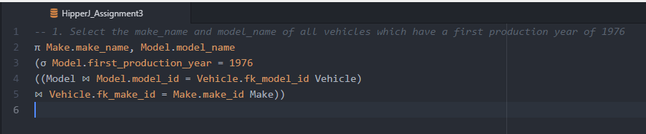

1. **Select the make_name and model_name of all vehicles with the color name Blue**

π Make.make_name, Model.model_name

(σ Color.name = "Blue"

((((Vehicle ⋈ Vehicle.fk_model_id = Model.model_id Model)

⋈ Vehicle.fk_make_id = Make.make_id Make))

⋈ Vehicle.vehicle_id = Inventory.fk_vehicle_id Inventory)

⋈ Inventory.fk_color_id = Color.color_id Color))

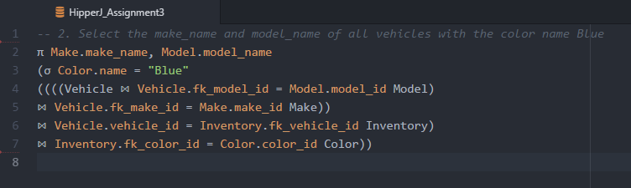

1. **Select the make_name, model_name and incentive amount for all vehicles with a dealer type incentive**

π Make.make_name, Model.model_name, Incentive.amount

(σ Incentive.type = "dealer"

((((Model ⋈ Model.model_id = Vehicle.fk_model_id Vehicle)

⋈ Vehicle.fk_make_id = Make.make_id Make)

⋈ Vehicle.vehicle_id = Vehicle_Incentive.fk_vehicle_id Vehicle_Incentive)

⋈ Vehicle_Incentive.fk_incentive_id = Incentive.incentive_id Incentive))

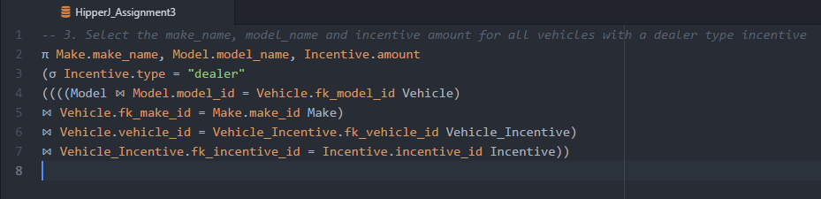

1. **Convert the following query to relational algebra**

**SELECT Player.id, Team.name, City.name FROM Player**

**INNER JOIN Team ON Player.team_id = Team.id**

**INNER JOIN City ON Team.city_id = City.id**

**WHERE Player.score = 100;**

π Player.id, Team.name, City.name

(σ Player.score = 100

((Team ⋈ Team.id = Player.team_id Player)

⋈ Team.city_id = City.id City))

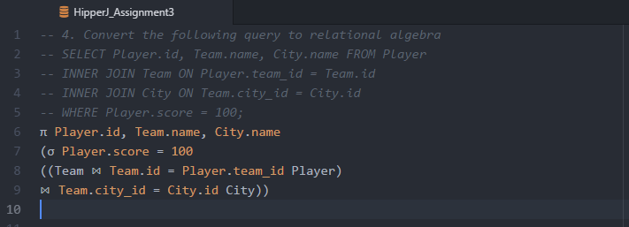

1. **For problem 3 above, convert your relational algebra query into a SQL query.**

SELECT Make.make_name, Model.model_name, Incentive.amount

FROM Model

INNER JOIN Vehicle ON Vehicle.fk_model_id = Model.model_id

INNER JOIN Make ON Make.make_id = Vehicle.fk_make_id

INNER JOIN Vehicle_Incentive ON Vehicle_Incentive.fk_vehicle_id = Vehicle.vehicle_id

INNER JOIN Incentive ON Incentive.incentive_id = Vehicle_Incentive.fk_incentive_id

WHERE Incentive.type = "dealer";

